Cameron Barlow

After concluding research on the foreign giving of the University of Virginia and comparing it to many other institutions, it is clear that we have many avenues in order to get more foreign aid. The Netherlands, Qatar, and China are all countries that we should be targeting in order to increase our revenue from foreign gifts. I say this because both China and Qatar have given the most of any country, but they have given the University of Virginia nothing. Thus, these countries obviously have the resources to give, we just need to find them. With the Netherlands, they have given other similar universities, like Boston College, way more money than us. Thus, we should also target them. Lastly, we should explore opportunities related to real estate in order to increase our revenue from foreign aid. This could be in looking at investors that may want to build foreign campuses, academic buildings, etc.

In looking at foreign giving as a whole, it is clear that there is a wide range of how much schools get. The schools that are getting the most money are those that graduate a lot of the richer people, like the Ivy League schools, as well as Carnegie Mellon. Furthermore, it can also be seen, as stated previously, that Qatar and China are foreign entities that give the most money. England and Bermuda are also countries that have given a lot. Lastly, in looking at foreign giving as a whole, it is important to note that many gifts are either monetary or contracts. While real estate type of gifts are rarer, these get more money on average.

In terms of looking at UVA and what we have received from foreign countries, a lot of our money has come from Europe and Asia. Bangladesh and Sweden have given us the most money, while countries like China and Qatar have not given us any money at all even though they have given the most money in total. A bar chart of our gifts can be seen below. Furthermore, all of our gift types are either monetary or contract, which could be seen as a missed opportunity for more money as well since real estate brings in the most on average.

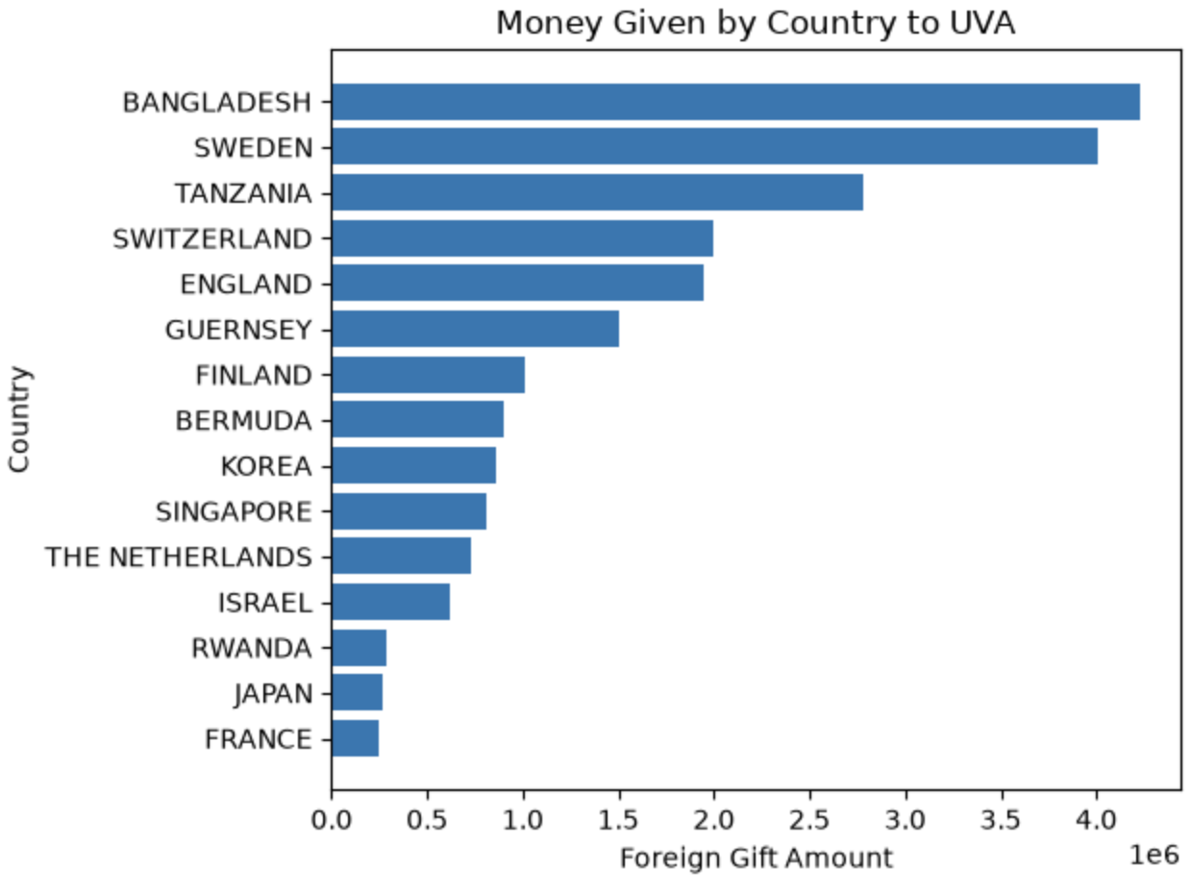

Furthermore, I looked at some institutions in the ACC to compare UVA to. One that stood out the most was Boston College, as they had less foreign gifts in total, but more money given to them than UVA. A big reason I found this to be is because the Netherlands gave them a lot of money, as well as China. This will be important in going forward with this analysis.

Certainly one strategy for UVA going forward is to do our best to explore opportunities in Qatar and China. I would say since China has given to Boston College as I saw, this certainly looks to be a great opportunity to get more money. That is certainly where I would start. Furthermore, I would also look at the Netherlands as a way to get more money. The Netherlands gave Boston College 31758049 dollars as compared to only 725670 dollars to us. Thus, there seems to be an opportunity here as well to expand the money we get from them as well. These are certainly the countries I would focus on, as they seem to be the best options at attracting more money to UVA.

Furthermore, as hinted at earlier, I feel UVA needs to do a better job at looking for foreign investors to look at building foreign campuses, academic buildings, and maybe some other type of real estate as well. This is a type of gift lacking from the foreign gift data of UVA, and it is an opportunity to make money as well.

Overall, UVA should feel like we are in a good position to expand resources through foreign gifts in a couple ways. China, Qatar, and the Netherlands should be important targets because they offer potential access to wealthy individuals and corporations. Furthermore, real estate is another area that UVA should explore because of the potential of significant money from this type of gift as well. In doing this, UVA should be able to see more success in terms of foreign gifts.

